The Pandemic Fund

Reporting Portal Word template
GENERAL
- All annual project reporting must be submitted through the Reporting Portal. This form has been developed as an optional working tool to assist project teams to consolidate findings before copy and pasting each section in the Reporting Portal.
- Note: It is also possible for several project collaborators to work together directly in the online portal. However, changes are not recorded and only the latest version is kept so users will need to coordinate the timing of their inputs to prevent overwriting data.
- Please note that:
  - Each answer has a limit of 15,000 characters in the portal (between 2150 and 3750 words with spaces included)
  - Formatting (fonts, bold, italics, underlining, etc) might not be correctly copied or saved from this Word document to the Portal. We recommend keeping formatting to a minimum in the Word template and then finalizing formatting once copied into the portal.
- Please consult Annex 1 Instructions for Year 1 Reporting, which provides the general overview of Reporting requirements and a step by step on how to use the Portal.

PROJECT REPORTING
- General Data
Reporting period start date (usually the date of grant signing – it’s January 31, 2024 for all the 1st grantees)
mm/dd/yyyy

Reporting period end date
Prefilled in Reporting Portal, no input required

Project overview
Copy and paste from proposal. Formatting may need to be redone in reporting portal, if relevant. Text 15,000 characters max.

Executive Summary (Concise summary of main takeaways from the report)
Text 15,000 characters

- Cross Cutting
Indicator 4E. Gender Equality. In what ways has the project considered and addressed issues related to gender equality?
Text 15,000 characters. Please refer to prompts in reporting portal for type of information to include in your response.

Indicator 4F: Health equity across underserved populations. In what ways has the project considered and addressed issues related to health equity across underserved populations?
Text 15,000 characters. Please refer to prompts in reporting portal for type of information to include in your response.

One Health. In what ways has the project considered and supported (will support) the One Health approach. Please share concrete examples.
Text 15,000 characters.

Community engagement. In what ways has the project considered and supported (will support) Community engagement. Please share concrete examples.
Text 15,000 characters

- Program Management and Implementation

Describe program management and implementation arrangements and indicate their effectiveness.
Text 15,000 characters.

- Quality of Monitoring and Evaluation

Describe the availability of quality data and the process for analyzing results for reporting. Indicate if there are any challenges with M&E capacity or systems of the project, and any proposed improvements in the next period.
Text 15,000 characters.

Describe how project results are disseminated to key stakeholders and used to inform project management, decision-making or course correction.
Text 15,000 characters.

- Risk management
Summarize any identified risks to the project. Describe any adverse effects to of these risks.
Text 15,000 characters.

Summarize any proposed mitigating measures to address risks, gaps or barriers affecting the project.
Text 15,000 characters.

- Achievements, Challenges, Lessons learned and Recommendations

Describe key project achievements from implementation to date. Provide concrete examples.
Text 15,000 characters.

Describe key challenges, barriers and gaps encountered in project implementation to date.
Text 15,000 characters.

Describe key lessons learned from implementation to date, positive and/or negative that may be applicable to other projects in the country or other countries. Provide suggestions or recommendations on how to improve project implementation.
Text 15,000 characters.

Case studies. Please provide 2-3 examples of how the Pandemic Fund support was used to overcome weaknesses, bottlenecks or challenges faced by the country/region. You can upload any pdfs in the Reporting Documents section.
Text 15,000 characters

If there are informational videos that capture the project achievements, interviews of key stakeholders and project beneficiaries where consent has been obtained for public use, please provide the URL/links.

Links

- Reporting documents
Upload the Annual Project Report (Excel reporting template, only .xls format accepted) – mandatory
[To be uploaded into Reporting Portal]

Other documents (You can upload several supporting documents in .xls, .pdf or .doc formats) – optional.
[To be uploaded into Reporting Portal]

ANNEX: INSTRUCTIONS FOR YEAR 1 REPORTING

The Pandemic Fund
General
- Year 1 reporting will be done through the Pandemic Fund online portal.
- It will consist of two parts:
  - The portal contains narrative reporting sections that can be filled out directly online. A Word template has been developed as an optional working tool to assist project teams to consolidate findings before copy and pasting each section in the Reporting Portal.
  - In addition, the project teams will fill out offline an Excel template for Reporting across the four Results Areas of the Pandemic Fund Results Framework. This Excel template will then be uploaded as an attachment in the portal.
- With few exceptions, reporting sections should be filled out for the project (and not per IE).
- All projects, whether single-country, multi-country, or regional project will provide a SINGLE consolidated report. The portal will allow per-country reporting for multi-country and regional projects in relevant sections. The Excel template has tabs where reporting for each country can take place, where relevant.
Part 1. Online narrative reporting
- Individuals listed as project leads or project collaborators will be granted access to the portal and receive an email with instructions on how to login in.
- Upon logging in, users will see a Menu on the left-hand side with data about the project.
- Click on the Project reporting section of the left-hand Menu.
- You will now see the submenu of the Project reporting section for Year 1 reporting. The menu includes: General Data, Cross Cutting, Program Management and Implementation, Quality of Monitoring and Evaluation, Risk Management, Achievements, Challenges, Lessons learned and Recommendations, and Reporting documents. 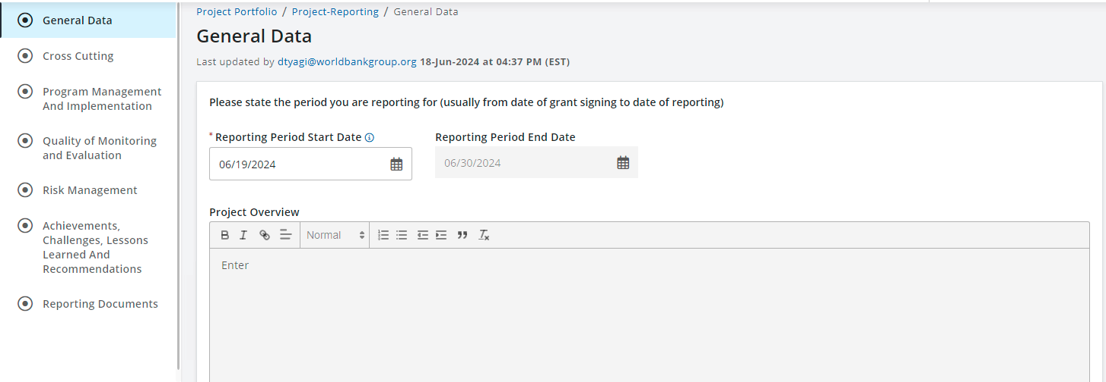
- You can easily navigate between the sections by clicking on them. Once you complete a section press the CONTINUE button at the bottom of each page, and your data will be saved.
- All sections with a red asterisk * are mandatory.
- General Data section: State the reporting period and fill out a project overview (it can be copied from the project proposal). Provide an executive summary of the Year 1 report. Click CONTINUE.
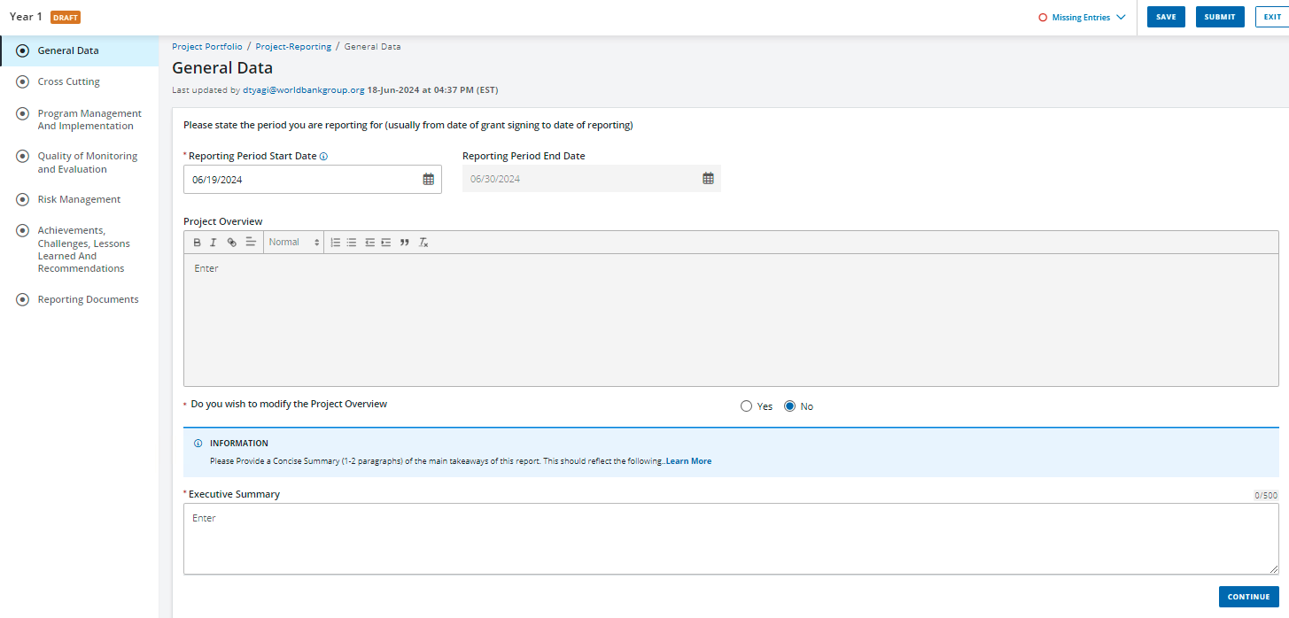
- Cross Cutting section: Provide a description and concrete examples on how has the project addressed Gender Equality, Health Equity, One Health and Community engagement
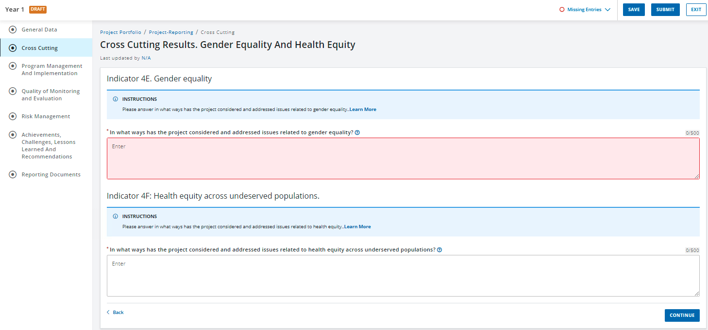
  - Gender Equality. In the Instructions section, when you click on “Learn More”, a pop up will appear with information on how the answers will be assessed.
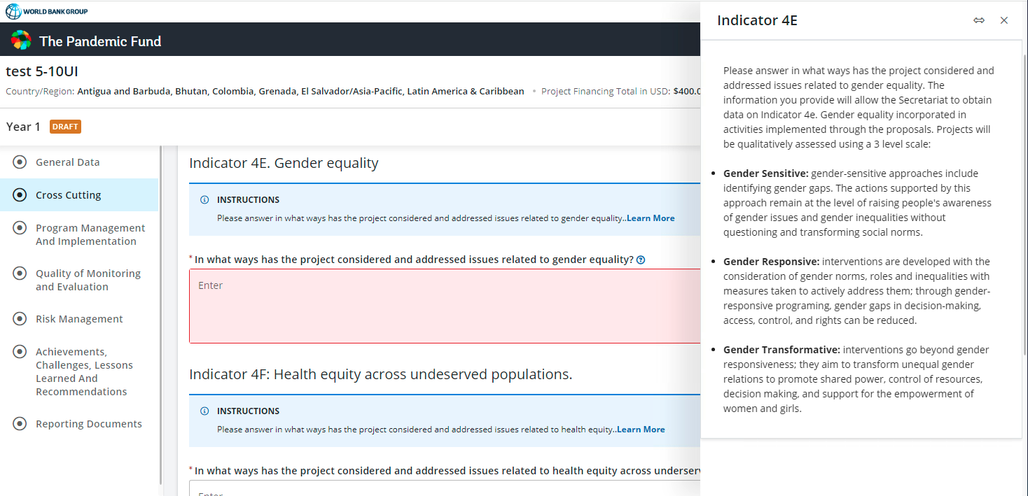
Click also on the interrogation sign (?) at the end of the question. A pop up will appear with guiding questions to help projects answer this section.
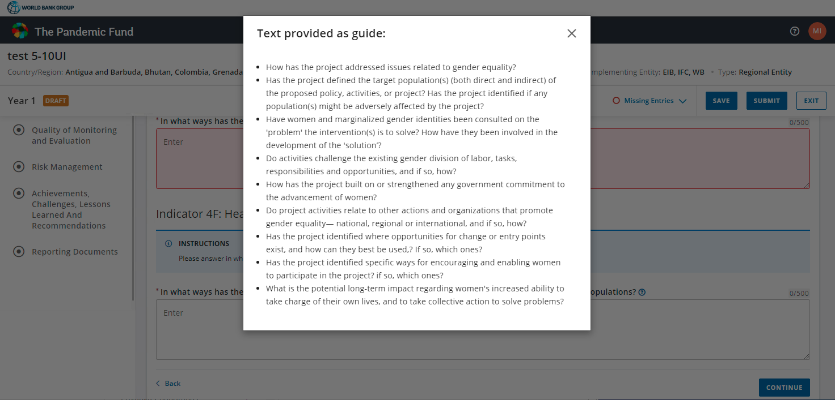
  - Health Equity across underserved populations. In the Instructions section, when you click on “Learn More”, a pop up will appear with information on how the answers will be assessed.
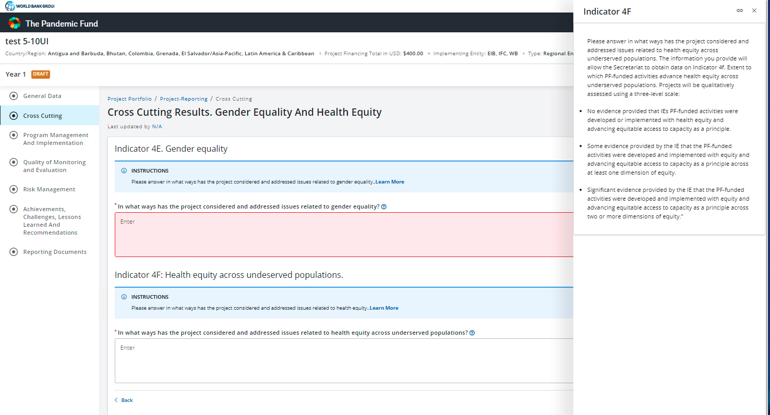
Click also on the interrogation sign (?) at the end of the question. A pop up will appear with guiding questions to help projects answer this section.
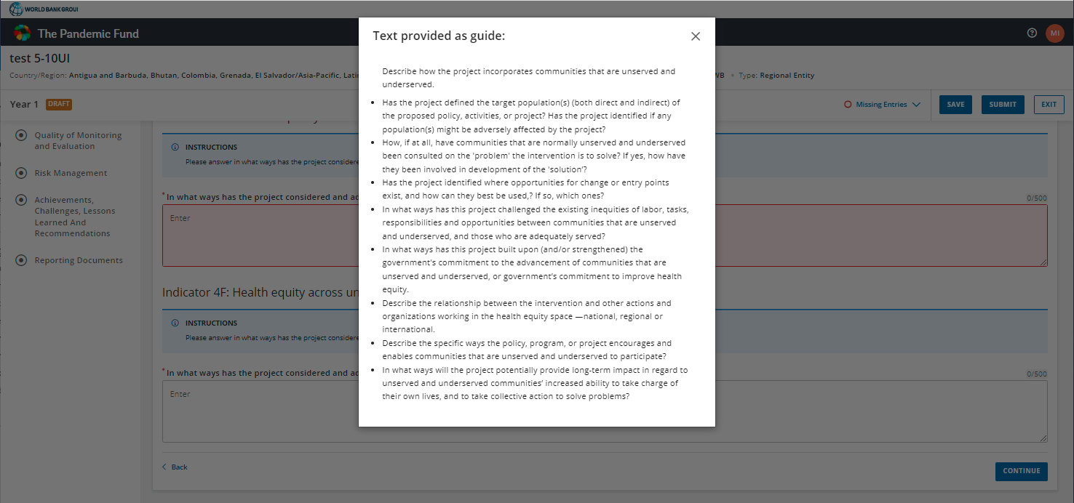
  - One Health. Fill out the answer to the question. Please share concrete examples

  - Community engagement. Fill out the answer to the question. Please share concrete examples
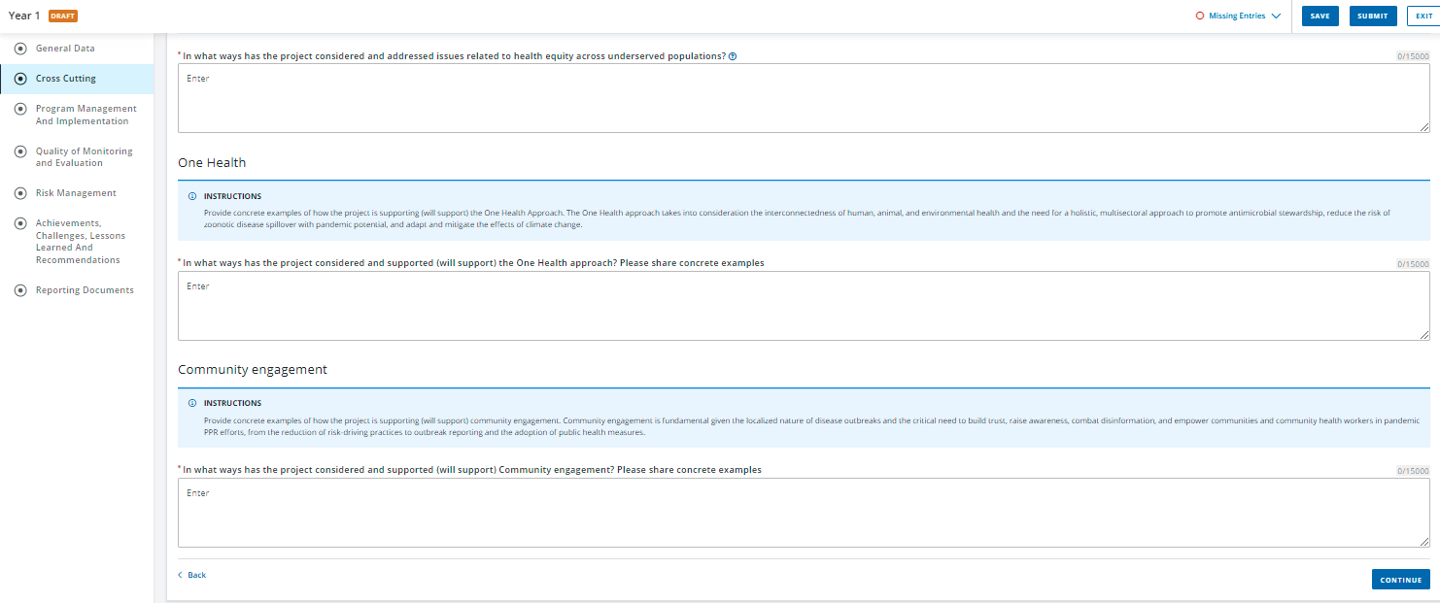
- Program Management and Implementation. Fill out the section with a description of the program management and implementation arrangements and an assessment of their effectiveness so far.
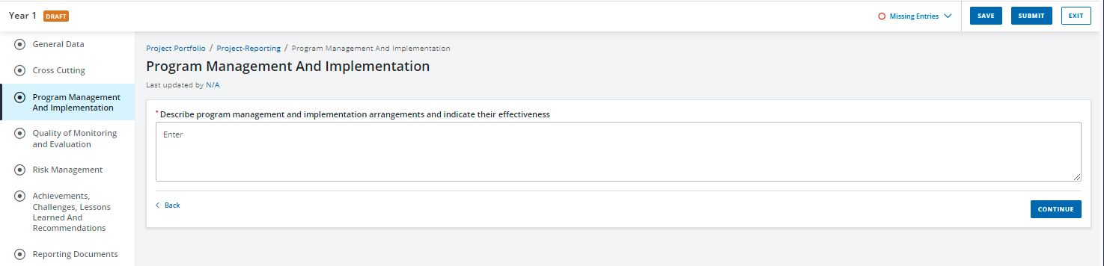
- Quality of Monitoring and Evaluation. Fill out the two sections required here, on the availability of quality data and M&E challenges, and on dissemination and use of results.
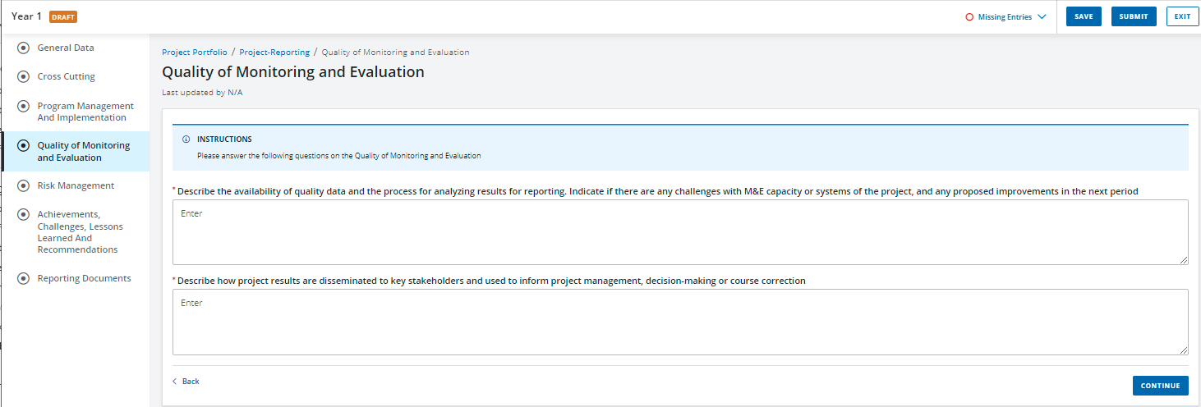

- Risk management. Fill the two sections required here on identified risks and their effects, and on mitigating measures.
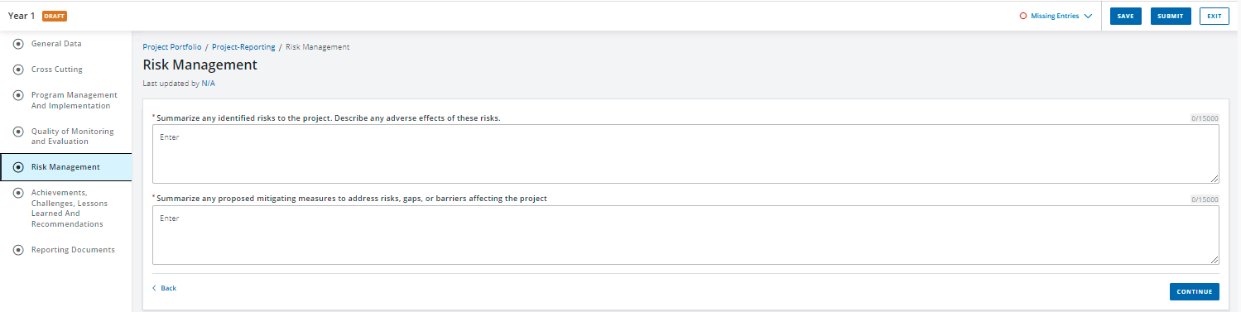
- Achievements, challenges, lessons learned and recommendations. Fill out the requested sections and provide concrete examples and case-studies where available. You can upload detailed case studies as supporting documents in the Reporting documents section.
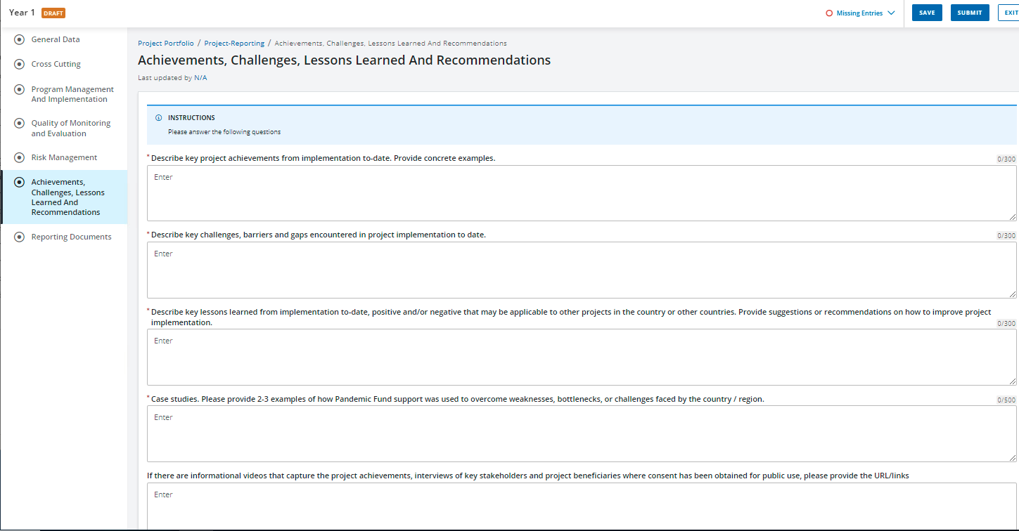
- Reporting documents. Upload the completed Excel reporting template as the Annual Project Report. You can also upload any other supporting documents, as relevant.
Part 2. Excel reporting template.
The Excel form should be completed as part of the Project Reporting for Year 1 for CfP1 grantees. It provides the PF Secretariat with the necessary data to compile the indicators in the Pandemic Fund Results Framework, across all four Results Areas. Please refer to the Pandemic Fund Results Framework Indicator reference sheets for detailed information on the indicators.
This Excel template complements the narrative reporting that will be completed in the Pandemic Fund's Reporting Portal, and must be uploaded in the Reporting Documents section. Please refer to the M&E Guidelines on the Pandemic Fund website to aid you in completing the template and the narrative reporting in the Portal.
The Excel template is structured with the following tabs:
- Instructions - This tab contains the same instructions you will find below. You do not need to complete anything on this tab.
- Country Results 1a (5x) - Single-country and Multi-country projects need to complete these tabs with baseline and result scores for each JEE/SPAR or PVS indicator in their proposals, organized under the relevant supported area. Regional Entity projects that have country-specific indicators, should fill out the necessary Country tabs.
  - One tab should be used for each country. If you have a Single-country proposal, you only need to fill out the tab "Country 1". You may duplicate the tabs if you have more than five countries by right-clicking on the blue "Country" tab, selecting "Move or Copy", and checking the box that says "Make a copy". Please rename each Country tab with the name of the country.
  - Inside each tab, please add one row per indicator.
  - The Secretariat requests that projects privilege SPAR indicators over JEE indicators where an equivalent indicator exists, as SPAR is conducted yearly and more recent data will be available. Projects can use JEE if the JEE was conducted in 2022-2024. You can find SPAR data in the WHO SPAR webpage, and JEE data on the WHO JEE webpage. You can find JEE -SPAR equivalencies in the tab of the same name, in this document.
  - If projects have non JEE/SPAR or PVS outcome level indicators, these can also be added here in separate rows and under the "alternative or subordinate outcomes" columns.
- Regional Results 1a- Regional Entity projects can use this tab to report on outcome level results at the regional level. If relevant JEE/SPAR or PVS indicators were chosen at the proposal stage to measure regional results, these can be added in the appropriate columns. If regional projects have non JEE/SPAR or PVS outcome level indicators, these can also be added here in separate rows and under the "alternative or subordinate outcomes" columns.
- Country Results 1b and 1c (5x) - Single-country and Multi-country should fill out this tab. Regional entity projects may fill out this tab for each country in their projects only if relevant, or if a relevant regional assessment similar to an AAR/IAR, EAR or simex was carried out in the period.
  - One tab should be used for each country. If you have a Single-country projects , you only need to fill out the tab "Country 1". You may duplicate the tabs if you have more than five countries by right-clicking on the blue "Country" tab, selecting "Move or Copy", and checking the box that says "Make a copy". Please rename each Country tab with the name of the country.
  - In Section 1, please add the number of total assessment reports (AAR, IAR, EAR, simex, etc) completed in the year, and then fill out one column per report. If no relevant assessments or simulations have been carried out, write 0 and leave the columns for each report blank.
  - In Section 2, please add, if relevant, 7-1-7 results obtained in each report. If 7-1-7 or other timeliness metrics were not used, leave blank.
  - In Section 3, please add JEE/SPAR or PVS indicators in your project, one per row. Provide information on whether the indicator score was sustained/increased or decreased during the reporting period. Then provide information on whether the capacity related to the JEE/SPAR or PVS indicator was measured and used effectively in each report.
- Country Results 1d- Single-country and Multi-country should fill out this tab with the percentage of PF projects’ activities that support gaps identified in countries’ National Action Plans for Health Security (NAPHS), or other relevant plans. Please add one row per country. Single country projects will only need to fill out one row.
- Results 2.
  - Indicator 2a. Regional Entity projects need to report on this indicator concerning regional networks and alignment with regional priorities for each of the supported areas in the project. This indicator may not apply to single-country or multi-country projects. If it does apply to your single or multi-country project, please complete.
  - Indicator 2b. Regional Entity projects need to report on this indicator concerning establishment or improvement of processes or mechanisms that allow for cross sectoral coordination WITHIN THE COUNTRY AND BETWEEN COUNTRIES during a public health emergency. This indicator may or may not apply to single-country and multi-country projects. Add one row per process or mechanism within or between countries. If there are process or mechanisms for several countries that you wish to report on, add them as additional rows and mention the country name in the name of the coordination mechanism (e.g. One Health coordination committee - Country A).
  - Indicator 2c. Single-country and Multi-country projects should fill out this indicator on the extent to which PF projects are implemented in coordination with multiple ministries, sectors, and stakeholders within the country. If reporting for multiple countries, add one row per country. Some Regional Entity projects might also want to report on this indicator if relevant to their projects.
- Results 3. All projects need to report on these indicators at the project (and not country) level.
  - Results 3a - Privide data on value of additional resources that are secured from stakeholders to support PF projects.
  - Results 3b - Provide an estimate on the amount of funding from PF that is used to complement/strengthen existing health security capacity building projects
- Results 4 .All projects need to report on these indicators at the the IE and/or at the project level (not at the country level). The data requested here complements data from the financial report sent to the Trustee, that is needed by the Secretariat to report to the Board. See definitions of terms in the Reporting Instructions document that was sent with this Excel template
  - Results 4b. Provide data on the total funds transferred to each IE in the project in the fiscal year, as well as funds disbursed by each IE to the project in the fiscal year ()
  - Results 4c. Provide data on project level administrative costs (estimated in the proposal) and administrative expenditures in fiscal year including project preparation, implementation, and supervision, as well as total project expenditures in fiscal year.
- Example Country Results 1a- You do not need to complete anything on this tab. It is included as an example of how country-specific reporting for Results 1a could look like. This should be used as a guide only.
- Example Country Results 1b and 1c- You do not need to complete anything on this tab. It is included as an example of how country-specific reporting for Results 1b and 1c could look like. This should be used as a guide only
- Example Results 3.You do not need to complete anything on this tab. It is included as an example of how reporting for Results 3 could look like. This should be used as a guide only.
- Example Results 4. You do not need to complete anything on this tab. It is included as an example of how reporting for Results 4 could look like. This should be used as a guide only.
- JEE -SPAR equivalencies: You do not need to complete anything on this tab. Here you can find the JEE-SPAR equivalencies.
In case of any questions, please email the Pandemic Fund at: pandemicfundcfp@worldbank.org

